## widgets table

## Fields

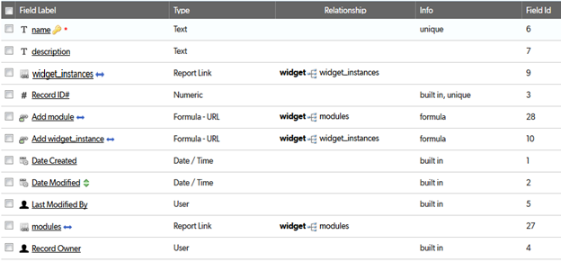

IMPORTANT! After you create this table, check its Advanced Settings. If it is NOT __dbid_widgets, then edit the CAMPER Common code page **make_program_copy.html** to update this value to match the actual widgets table alias.

## Relationships

## 

## 

## Field settings

Note: Built-in fields use the default settings

name 3

description 3

instances 3

Add module 3

Add widget_instance 3

modules 3

# name

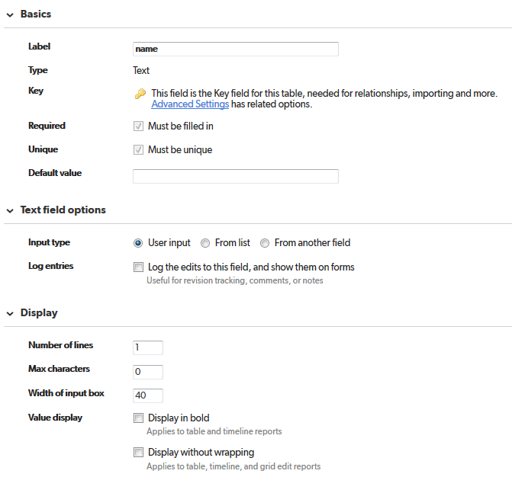

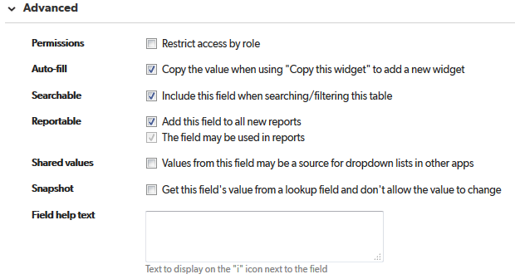

# description

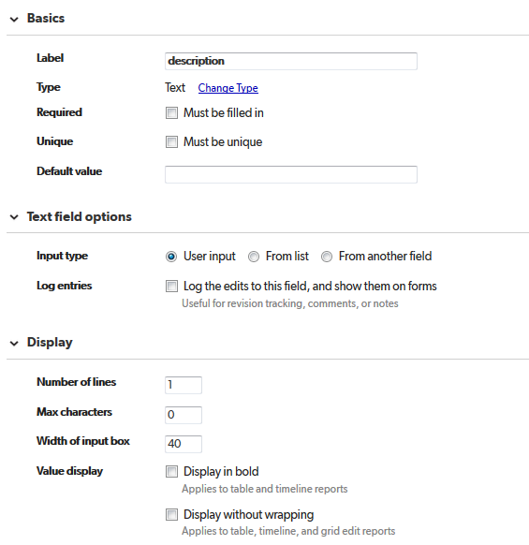

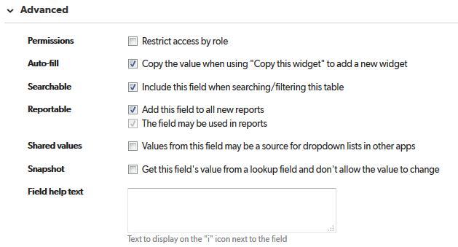

# instances

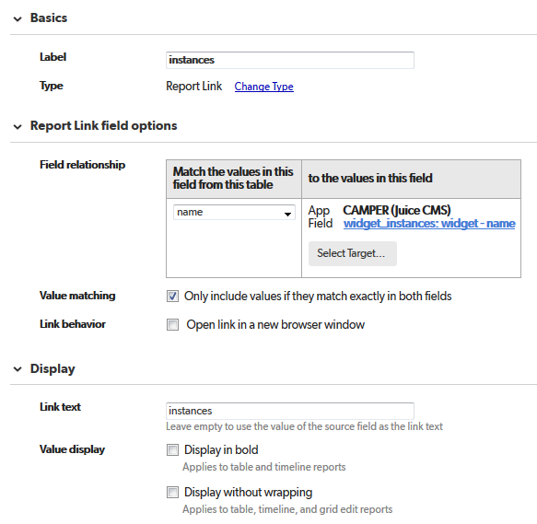

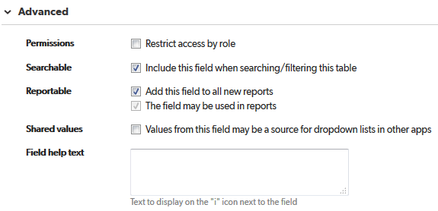

# Add module

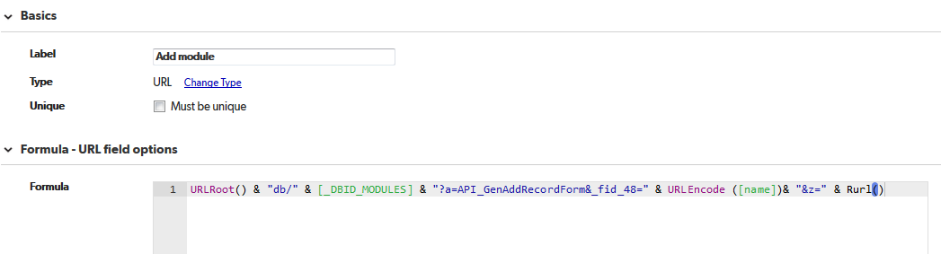

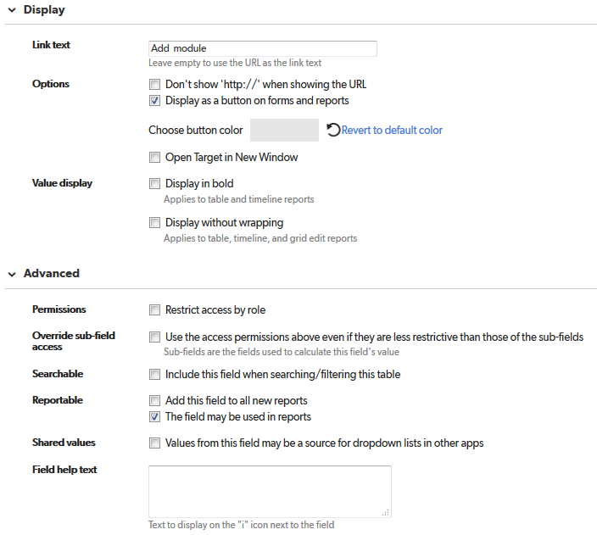

# Add widget_instance

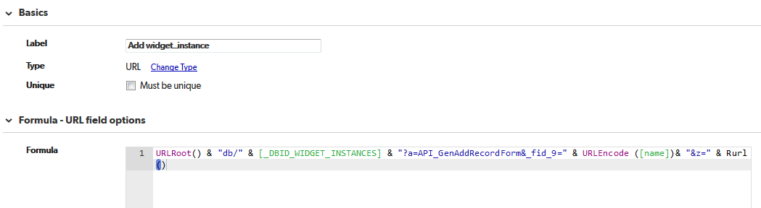

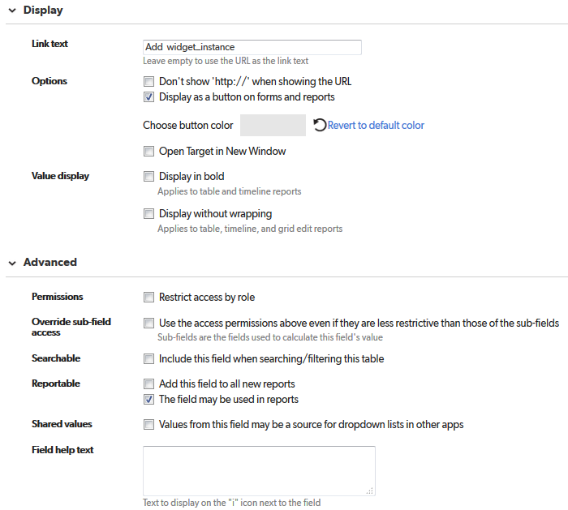

# modules

